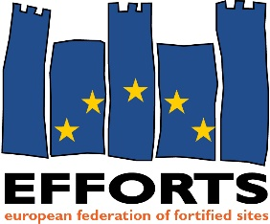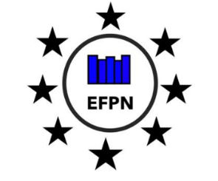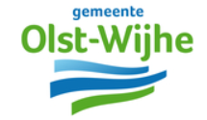

EFFORTS Olst-Wijhe
16 May Workshop ‘Between the Lines’

-Welcome by Mayors Ton Strien (Olst-Wijhe) and Lex Roolvink (Grave).
Olst-Wijhe
Europen values testimony.
Projects in tourism
Partners : Ministeries of Culture, Defense
Concrete projects :
-Sustainability
-Come towards an exchange between young and old, between old enemies
-Cultural heritage can make breakthrough
-Edwin Teurlincx : Acting in the EU.
- Municipalities alone cannot act in Brussels at EU level. Need to look for partners : regional, provinces, national level and EFFORTS.
Actions by local authorities at EU level:
-Grants : the goal of most of EU efforts in Brussels
-Lobby - ctions towards proposals and execution of EU regulations. Municipalities can do bottom-up work : inform ‘higher’ authorities
-Positioning ; inform Brussels on your identity and interests
-Network and knowledge sharing : between colleague-organisations, EU reps.
-Focus on max. 3 main topics for lobby actions
-Engage members and collaborators / provide capacity in home country
(ex. Commission Mapping of Cultural Heritage Actions 2017)
EU priorities today : sustainability, digitalisation, security. These are EFFORTS issues.
-Volunteer work
-Cross-over issues in projects are important
-EU wants to focus on the intermediate size cities
-Den Bosch : focus on digitalisation, heritage, …
Need for budget and public / political support.
Adaptive reuse, new public functions and space, events venue.
Ex : Tourism, Urban Innovative Actions, Horizon Europe, Structural funding (Interreg), EYCH2018
Europa Nostra-prize candidate
Zuiderwaterline in Netherlands : limit between religions, geography, water management regions, war defenses : in Netherlands, Europe (Poland, Denmark, Germany, France)
-Shared heritage (European history, values)
-Use of knowledge of the old days : from defence to retention – use adaptive reuse or climate challenges
-Big data,
-Empowerment and social inclusion
How to go into action :
- Analysis of the situation. Link with today’s challenge solutions (climate adaptation, innovation, digitalisation, social empowerment)
- Include stakhoders and beneficiaties (other governments, local support)
- Check local, regional, national issues for policy formulation
- Use relevant networks with EU scale : EFFORTS.

- EFFORTS (see presentation)
-Zuiderwater-line : setting-up of a programme for action : renovation, tourism development, European vision: knowledge sharing of hidden heritage for use in solutions to present challenges
-Zutphen : Stâdtebund Die Hanse , sustainable mobility, CO2-reductions, housing, culture, renovation, reuse. Already active in European projects : funding and knowledge sharing Interreg A Tourism, climate adaptation, AAL storytelling
-Foundation Ijssel-line : historic European connection : translation to today’s relevance of such heritage.
-Culemborg : digitalisation, heritage, augmented reality, climate adaptation, regional research energy transition study: proposals for regional policy. Therefore need for knowledge development : inundation canalisation. Via Nieuwe Hollandse Water-line, Stelling van Amsterdam, provincial cooperation, with other cities.
-Nieuwe Hollandse Water-line : national monument, UNESCO heritage label, watermanament, military fortifications. Exceptional intact example for European defence system. Actions on climate, set-up of eductional programmes – exchange. Sibenik’s interest for example
-Groenlo : 18-19-20 October international conference on 80-year war. EFFORTS is partner
- Heusden : 2029 anniversary of 80-year war siege is center of action. REgional and inter-municipal collaboration. Need for more than only presentation on history : how to connect with today’s challenges. Search for new functions that connect with the ‘story’. Important : keep your finger on the property changes of forts, fortification for change of function.

Conclusions : continue this with Europe partners at EFFORTS side-event at Week or Regions Committee of the Regions
Stichting Liniebreed Ondernemen : entrepreneurship on fortifications and fortified cities, communication and management of line-models in Netherlands. Co-organisator of EFFORTS European Fortress Days, a European communication platform.
Wellington barrier : Luxembourg, Dutch and Belgian partner cities and knowledge institutions, + UK, FR : 25/4 startconference in Namen : come to European Boulevard EU project June 2019.

RD

NOTES :
- Presentatie Ton Strien
- Foto’s Marit
- Foto Bernou, save the date-digital
- Note Huib
- Sturen verslag EHA 33 to Edwin

